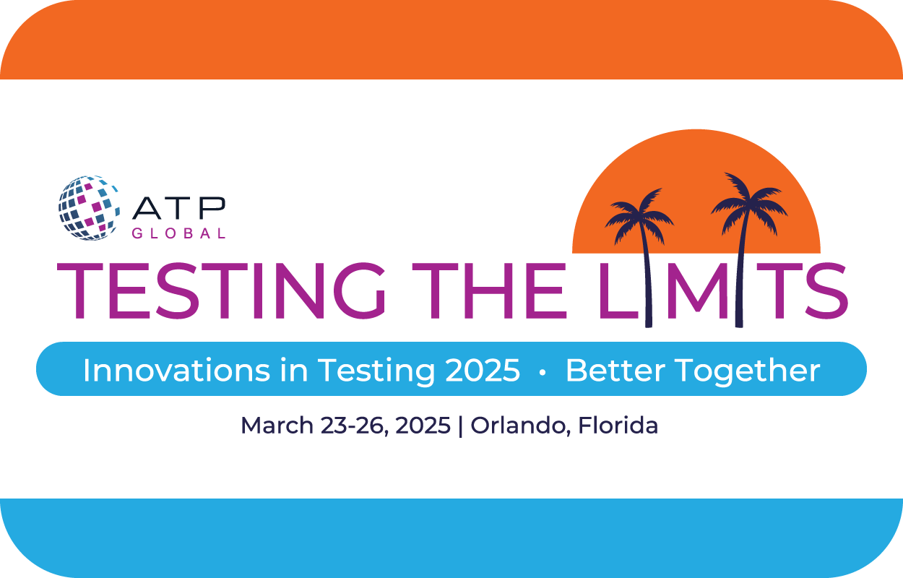

ROI Toolkit

How to Convince Your Leadership
to Send You to Innovations in Testing 2025

This resource is your go-to guide for making a compelling case for attending the 2025 Innovations in Testing Conference. Whether you're aiming to enhance your skills, network with industry leaders, or bring back cutting-edge insights to your team, our toolkit equips you with the strategies, data, and persuasive techniques needed to secure your leadership’s approval. Dive in and get ready to transform your professional growth ambitions into reality.

Email Your Decision Maker

Hi <Insert Name>,

I have a strong interest in attending the 2025 Innovations in Testing Conference in Orlando, FL from March 23-26, 2025. Hosted by the Association of Test Publishers (ATP), this conference brings together industry leaders and innovators to share the latest trends, technologies, and best practices in the field of testing. I’m confident that attending will bring significant benefits for both my professional development and our organization.

Key benefits of attending:

- Innovative Learning: Learning how organizations can innovate and discover new ways to provide stakeholder value, improve assessment outcomes, and create assessments that are bridging opportunities for better assessment
- Valuable Networking: Making valuable connections through numerous engaging networking opportunities. I will meet and connect with thought leaders and industry colleagues addressing similar challenges. This may lead to potential joint venture partners or subcontractors who can enhance our business.
- Insightful Discussions: Discussing the value and purpose of assessment with thought leaders from various markets, including education, credentialing, clinical, and industrial/organizational markets.
- Collaborative Opportunities: Collaborating to improve efficiency of learning, renew the value of assessment, and leverage best practices to drive better outcomes.

The Innovations Conference is the testing community conference for newcomers and experts alike. There will be several sessions focused on <insert topic related to job role>, which I can apply immediately in my work after the conference, as well as topics like, <insert topic related to job role> which will further broaden my knowledge base. I have attached a “Benefits Worksheet” outlining how this conference will provide value. After the conference, I plan to <insert plan, i.e “conduct a workshop to share the key insights with our team>.

Best of all, Innovations is renowned for promoting collaboration through its many networking events. Connecting with like-minded individuals and understanding how they manage similar circumstances will be extremely valuable to my future professional support and growth initiatives.

Attending the conference will cost approximately <insert cost from expense worksheet> including transportation, hotel, sessions, events, and meals. I’ve identified ways to save money, such as <insert cost-saving ideas>. A detailed breakdown of the costs is attached.

I kindly request your approval to attend the 2025 Innovations in Testing Conference. Thank you for considering my request. I’m happy to discuss this further or provide any additional information you may need. I’m confident that the knowledge and connections gained from attending this conference will yield significant value for our organization.

Thank you for your consideration.

<Insert your name>

Attach the Benefits Worksheet
Use this worksheet to highlight the valuable insight and knowledge that you'll bring back to your company by attending the 2025 Innovations in Testing Conference in Orlando, FL. Simply list the opportunities that will help you grow as a professional and that will also help you tackle industry challenges. Once the program listing is available, you can follow up to provide more detail about specific sessions you are planning to attend. The full program listing will be available on the conference website, so make sure to check regularly for updates.

Topic Covered | Focus of Sessions | Benefits
Trending or Disruptive Technologies | Emerging/novel technologies, new uses for existing technologies, innovative approaches, and disruptive methodologies (process/technology related)
Business Strategy and Program Design | Program policies, growth/marketing strategies, stakeholder impacts, communication, accreditation, and best practices
Legal and Policy Considerations | Ethics, legislation, regulation, guidance, standards, and policies
Test Development and Psychometrics | Content development, psychometric models, item bank management, exam formats (linear, LOFT, CAT, Observational, Labs), advanced item development (rich media, simulations, etc.)
Security | Data privacy, fraud prevention/detection/enforcement, data protection, forensics, and data analytics
Test Administration and Delivery | Test delivery methods, standards, stakeholder considerations, and candidate experience
Equity, Accessibility, and Diversity | Inclusive methods/practices (content development, candidate experience), stakeholder considerations, accessibility/accommodations approaches

Attach the Estimated Expense Worksheet
Use this handy worksheet to organize your estimated expenses. Simply fill in the estimated amounts for each item in the cost column, and you’ll have a clear picture of your conference budget.

Expense | Information | Cost
Registration fee | Check to determine if you qualify for a member or early bird discount. | $ -
Flight | Use the internet for an estimate and consider baggage fees if applicable. | $ -
Hotel | Hyatt Regency Orlando, Orlando, FL. Book in advance through ATP for a discount. | $ -
Transportation from  airport to hotel and back | 12.3 miles from the airport.  Uber or Lyft: averages $25 each way  Taxi: averages $45-55 each way | $ -
Mileage  reimbursement | Are you driving to the conference? Or do you need to take your vehicle to the airport? | $ -
Parking | Self-parking is available at the Hyatt Regency Orlando at a rate of $35.00 for overnight guests.  Valet Parking: $50 | $ -
Food | The following meals are included with your conference pass: Breakfast on Monday, Tuesday, and Wednesday, Lunch for Monday and Tuesday, along with breaks and receptions. Account for meals you may need while traveling to and from the conference. | $ -
Miscellaneous | Are there any other expenses associated with attending the conference? | $ -
 | Total | $ -

